Task 1

CREATE TABLE Studentinfo (

STU_ID INT PRIMARY KEY,

STU_NAME VARCHAR(255),

DOB DATE,

PHONE_NO VARCHAR(15),

EMAIL_ID VARCHAR(255),

ADDRESS VARCHAR(255)

);

-- Create Coursesinfo table

CREATE TABLE Coursesinfo (

COURSE_ID INT PRIMARY KEY,

COURSE_NAME VARCHAR(255),

COURSE_INSTRUCTOR_NAME VARCHAR(255)

);

-- Create Enrollmentinfo table with foreign key constraints

CREATE TABLE Enrollmentinfo (

ENROLLMENT_ID INT PRIMARY KEY,

STU_ID INT,

COURSE_ID INT,

ENROLL_STATUS VARCHAR(20), -- You can use an enum or foreign key to a status table for more control

FOREIGN KEY (STU_ID) REFERENCES Studentinfo(STU_ID),

FOREIGN KEY (COURSE_ID) REFERENCES Coursesinfo(COURSE_ID)

);

INSERT INTO Studentinfo (STU_ID, STU_NAME, DOB, PHONE_NO, EMAIL_ID, ADDRESS)

VALUES

(1, 'Namit Goyal' , '1995-05-12', '6876543205', 'namit.goyal@gmail.com', '111, Lajpat Nagar, Indore'),

(2, 'Abhilasha Gour', '1998-08-25', '8749804640' , 'abhilasha.gour@gmail.com', '444, Avantika Nager, Dewas'),

(3, 'Rahul Patel', '1997-03-10', '8664643109' , 'rahul.patel@gmail.com', '888, Lake Road, Bangalore');

INSERT INTO Coursesinfo (COURSE_ID, COURSE_NAME, COURSE_INSTRUCTOR_NAME)

VALUES

(101, 'Computer Science', 'Dr. Neha Verma'),

(102, 'Electrical Engineering', 'Prof. Rajesh Singh'),

(103, 'Economics', 'Dr. Abhilasha Singh');

INSERT INTO Enrollmentinfo (ENROLLMENT_ID, STU_ID, COURSE_ID, ENROLL_STATUS)

VALUES

(501, 1, 101, 'Enrolled'),

(502, 2, 102, 'Enrolled'),

(503, 3, 101, 'Enrolled'),

(504, 1, 103, 'Not Enrolled');

Task.1.3.a

SELECT s.STU_NAME, s.PHONE_NO, s.EMAIL_ID, e.ENROLL_STATUS

FROM Studentinfo s

JOIN Enrollmentinfo e ON s.STU_ID = e.STU_ID;

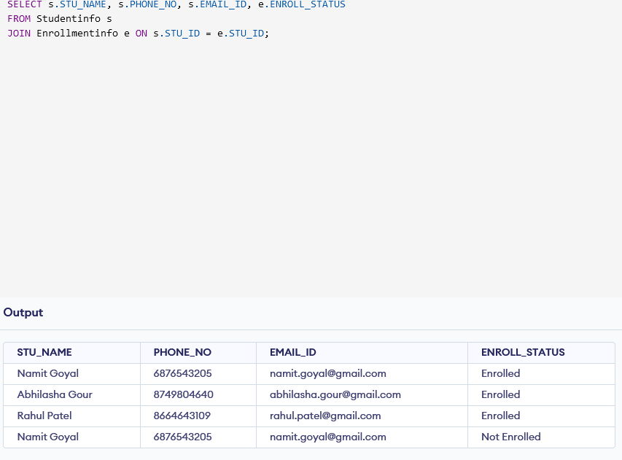

Task1.3.b

SELECT c.COURSE_NAME

FROM Coursesinfo c

JOIN Enrollmentinfo e ON c.COURSE_ID = e.COURSE_ID

WHERE e.STU_ID = 1;

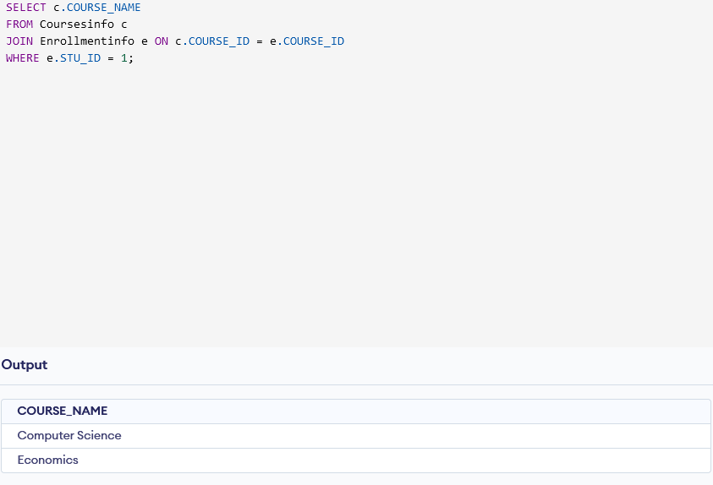

Task1.3.c

SELECT c.COURSE_NAME, c.COURSE_INSTRUCTOR_NAME

FROM Coursesinfo c;

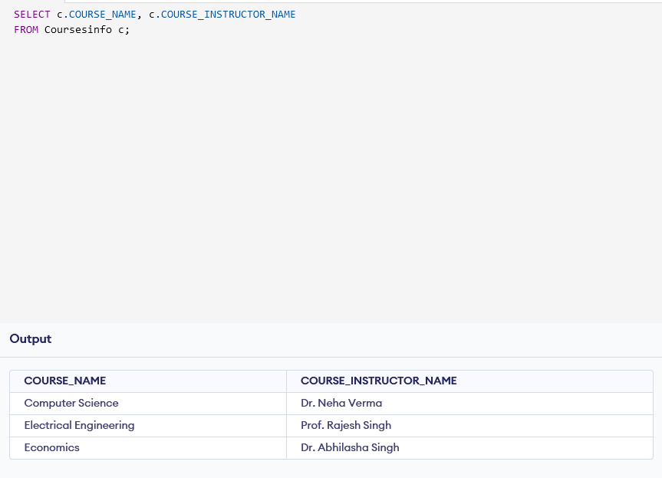

Task1.3.d

SELECT c.COURSE_NAME, c.COURSE_INSTRUCTOR_NAME

FROM Coursesinfo c

WHERE c.COURSE_ID = 101;

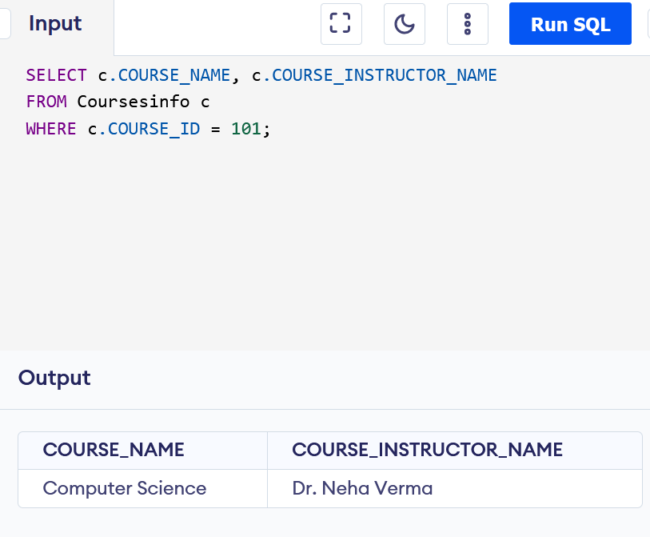

Task1.3.e

SELECT c.COURSE_NAME, c.COURSE_INSTRUCTOR_NAME

FROM Coursesinfo c

WHERE c.COURSE_ID IN (101, 102);

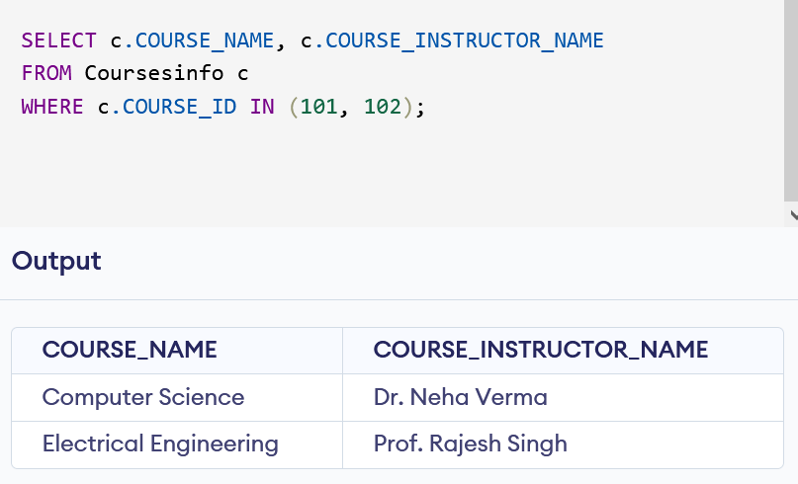

Task.1.4.a

SELECT c.COURSE_NAME, COUNT(e.STU_ID) AS Enrolled_Students

FROM Coursesinfo c

LEFT JOIN Enrollmentinfo e ON c.COURSE_ID = e.COURSE_ID

GROUP BY c.COURSE_NAME;

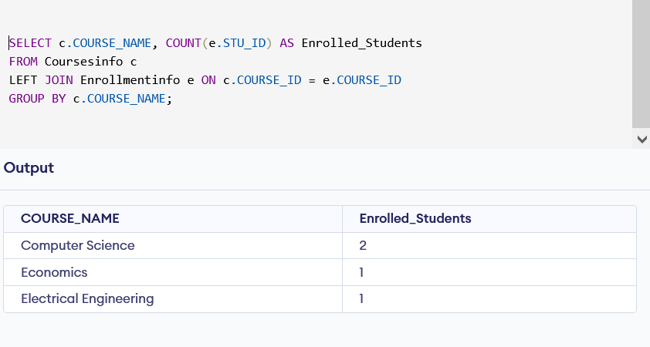

Task 1.4.b

SELECT s.STU_NAME

FROM Studentinfo s

JOIN Enrollmentinfo e ON s.STU_ID = e.STU_ID

WHERE e.COURSE_ID = 101;

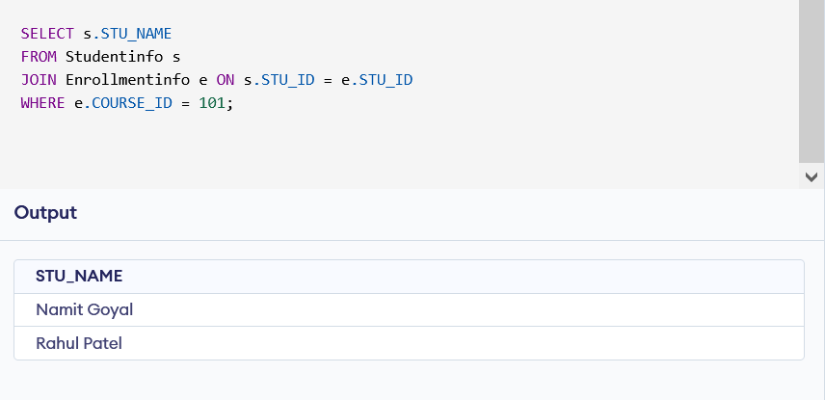

Task1.4.c

SELECT c.COURSE_INSTRUCTOR_NAME, COUNT(DISTINCT e.STU_ID) AS Enrolled_Students

FROM Coursesinfo c

LEFT JOIN Enrollmentinfo e ON c.COURSE_ID = e.COURSE_ID

GROUP BY c.COURSE_INSTRUCTOR_NAME;

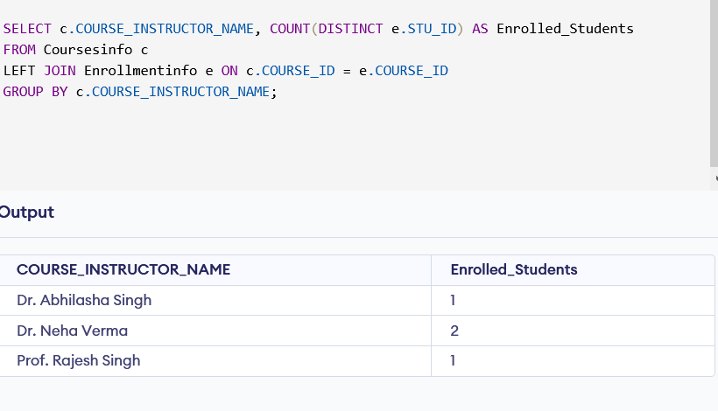

Task 1.4.d

SELECT s.STU_NAME, COUNT(e.COURSE_ID) AS Enrolled_Courses

FROM Studentinfo s

JOIN Enrollmentinfo e ON s.STU_ID = e.STU_ID

GROUP BY s.STU_NAME

HAVING COUNT(e.COURSE_ID) > 1;

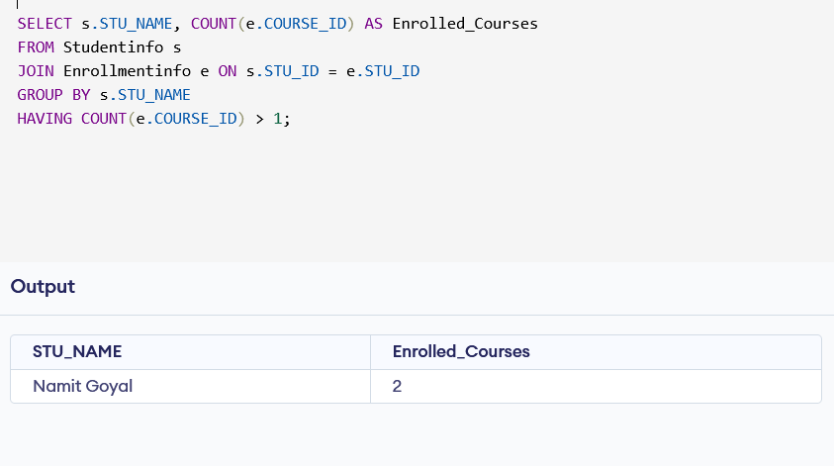

4e

SELECT c.COURSE_NAME, COUNT(e.STU_ID) AS Enrolled_Students_Count

FROM Coursesinfo c

LEFT JOIN Enrollmentinfo e ON c.COURSE_ID = e.COURSE_ID

GROUP BY c.COURSE_NAME

ORDER BY Enrolled_Students_Count DESC;

